Onyekwelu, Kenechukwu Department of Medical Biochemistry, College of Medicine, University of Nigeria, Enugu Campus, Enugu State, Nigeria. emailkene@yahoo.com. July 18th, 2016.
Editor-in-Chief Asian Journal of Medical Sciences
Sir,
We are pleased to submit an original research article entitled ‘’ Oxidative stress/lipid peroxidation and antioxidant enzymes in apparently healthy individuals involved in physical exercise.’’ for consideration for publication in your Journal.
Upon acceptance by Asian Journal of Medical Sciences, all copyright ownership for the article is transferred to Asian Journal of Medical Sciences. We, the undersigned co-authors of this article, have contributed significantly to and share in the responsibility for above. The undersigned stipulate that the material submitted to Asian Journal of Medical Sciences is new, original and has not been submitted to another publication for concurrent consideration.
We also attest that any human studies undertaken as part of the research from which this manuscript was derived are in compliance with regulation of our institution(s) and with generally accepted guidelines governing such work.
We further attest that we have we have no conflicts of interest to disclose and that the manuscript has been seen and approved by all authors.
Thank you for your consideration!

Sincerely,
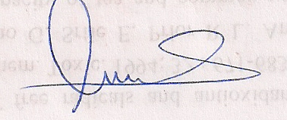
Onyekwelu Kenechukwu (On behalf of all the authors)

