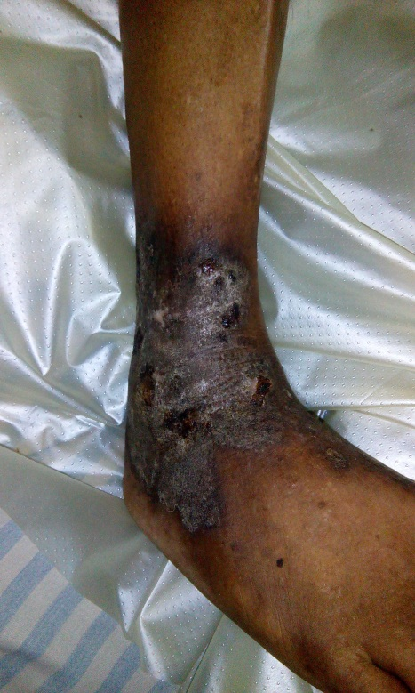
Figure 1. Chronic eczematous lesion

