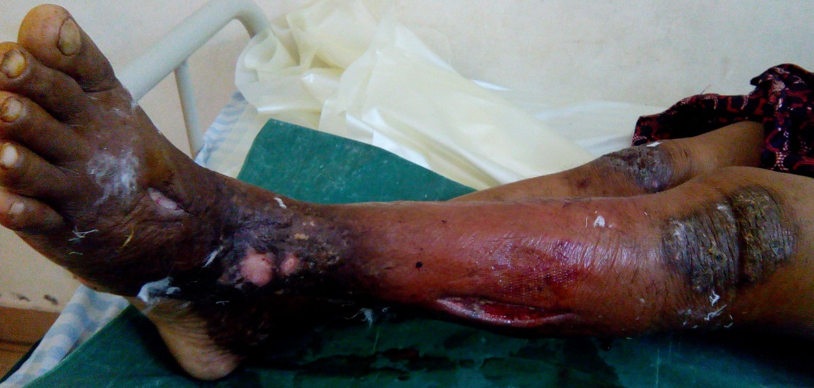
Figure 1. Necrotizing fasciitis of left lower limb post fasciotomy and debridement

