Covering letter
Date: 7th June, 2017

To
The Editor,
Asian Journal of Medical Sciences
Sub: Submission of Manuscript for publication

Dear Sir,
We intend to publish an article entitled “Present perception on gender related aspects among tribal mothers of Kalyani, West Bengal” in your esteemed journal as an Original Article. On behalf of all the contributors I will act and guarantor and will correspond with the journal from this point onward. This has been seen and approved by the co-author.
The copyright disclosure statement is enclosed herewith with signature of all authors.
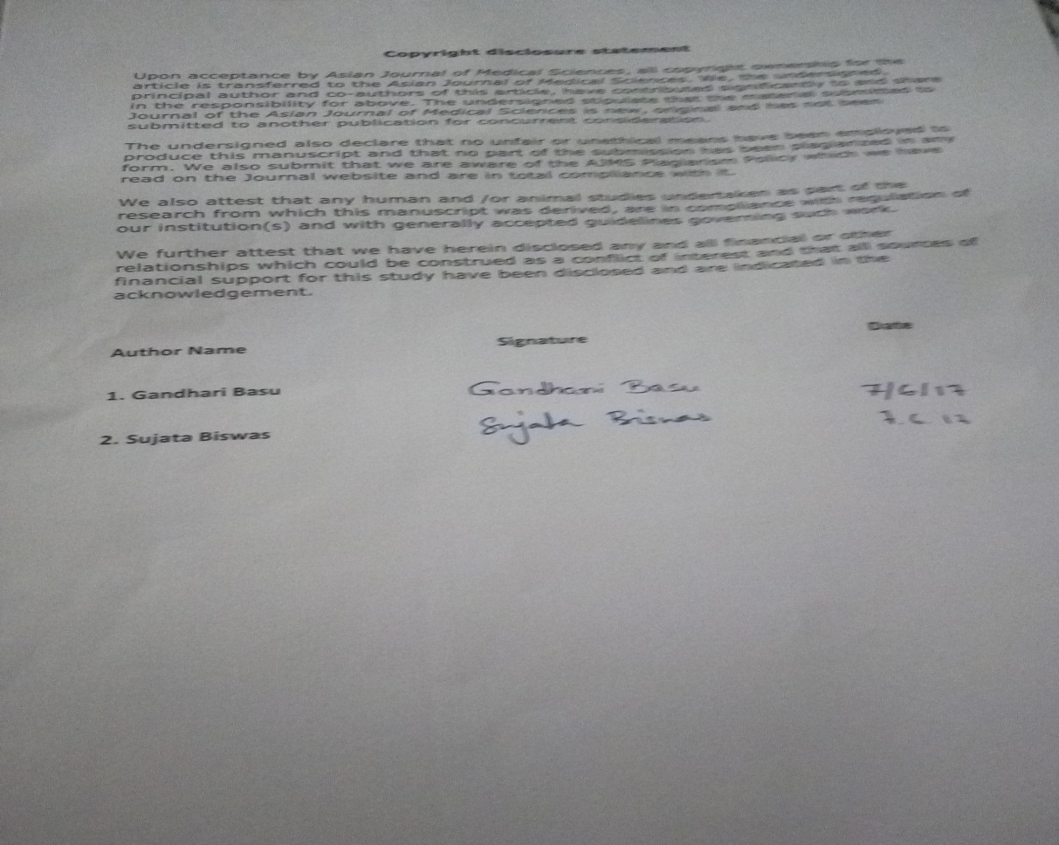
Thanking you,
Gandhari Basu

