To
Dr.Arun Kumar
Professor of Biochemistry
The editor in chief
Asian Journal of Medical Science,
Sir,
I am sending the following required corrections for publication in your journal as per your E-mail Dated 26.04.2018.
Original article: “ To compare advantage of non-fixation versus fixation of mesh in laproscopic TEP repair of inguinal hernias”
Dr. Ambar Gangopadhya¹ ,Dr. Bikash Chandra Ghosh²
¹Associate Professor, Department of General Surgery ,R .G .Kar Medical College Kolkata
²Associate Professor, Department of General Surgery ,R.G .Kar Medical College Kolkata
Postal address of author : Dr. Ambar Gangopadhyay
Dr. Gopal Chatterjee Road, P.O.- Sukchar,Dist- 24 Pgs(North),
Kolkata-700115,West Bengal,India.
Corresponding author: Dr. Bikash Chandra Ghosh
Department of General Surgery,R.G.Kar Medical College,
1 ,Khudiram Bose Sarani, Kolkata-700004.,West Bengal, India.
Postal address of corresponding author: Flat no.:6/2c,Regent Ganga Complex, 9,K G.T. Road ,P.O.-Bhadrakali, Pin code -712232,Dist- Hoogly,West Bengal ,India. E-mail id : drbikashghosh@gmail.com Tel No.: +919433032989/+919830866996
Running title :”Advantage of non-fixation of mesh in TEP”.
Concept and design of the study: Randomized controlled study.
Sample design:
For random allocation of surgical intervention measures, sixty (60) empty envelopes were taken and numbered from 01 to 60. Odd numbers were specified for the fixation group and even for non fixation group. Determining direction of movement beforehand, first number was selected from the random number table, with the help of a pen. The number was written on a piece of paper and entered into the first envelope, numbered 01.Subsequently remaining odd and even numbers were selected from random number table, till desired sample size was reached. The envelopes were sealed. The first patient with inguinal hernia, attending department after initiation of data collection, fulfilling all the inclusion and exclusion criteria was provided with the first envelop and intervention measures were taken accordingly. Remaining envelops were distributed to other patients coming afterwards fulfilling the exclusion and inclusion criteria.
Contributions:
AG :Concept and design of the study,manuscript preparation,staststically analysed ,and interpreted ,critical revision of manuscript,collected data.
BCG :Reviewed literature and helped in preparing first draft of manuscript,data collection.
Work attributed to :
Department of General Surgery ,R .G .Kar Medical College, Kolkata.
Orcid ID:
Dr. Ambar Gangopadhyay :http://sandbox.orcid.org/0000-0002-2725-0945
Dr.Bikash Chandra Ghosh :http://sandbox.orcid.org/0000-0002-4958-1737
Source of funding: R.G.Kar Medical College,Kolkata.( All operations done in this Government Medical College ).
Acknowledgement : Post-graduate Trainees and all staffs of Department of Surgery, R.G.Kar Medical College, Kolkata.
Conflict of interest : None.
Abstract :
Background : To compare advantage of non-fixation versus fixation of mesh in laparoscopic TEP repair of inguinal hernias.
Aims and objective:
This study was done for analysis of outcome in regards to intra and postoperative complication, number of hospital stay, recurrence, pain regarding the procedure between fixation and non fixation of mesh in totally extra peritoneal repair of inguinal hernia.
SPECIFIC OBJECTIVES OF THIS STUDY:
- To evaluate post operative complications between fixation and non fixation of mesh in totally extra peritoneal repair of inguinal hernia.
- To evaluate recurrence between fixation and non fixation of mesh.
- To evaluate long term groin pain between fixation and non fixation of mesh.
Broad objectives:
To evaluate the necessities regarding the fixation of mesh in case of totally extra peritoneal inguinal hernia repair.
Materials and methods:
The study was carried out in the Department of Surgery, R.G.Kar Medical College and Hospital from Janury 2011 to April 2012. All patients admitted in General surgical unit presenting with uncomplicated inguinal hernias were included.
Total 60 patients were included in the study, 30 patients underwent TEP repair without mesh fixation and in remaining 30 patients the mesh was fixated using metallic tacks.
Medically unfit persons having previous midline or paramedian incisions and obstructed hernias were excluded from the study.
Parameters used for comparison were
- Duration of operation
- Intra and Post operative complication
- Duration of hospital stay
- Long term groin pain
- Recurrence
Results :
Difference in average pain score at first 12 hrs was not statistically significant
(p = .060) but at 24 hrs, 72 hrs, 1 month and 6 months was significant statistically (p =
.003, p = .003, p = .000, p = .001 respectively). There was no recurrence in either of
the groups (fixation vs. non fixation).Complications were more in fixation group, but this
was not statistically significant. Hospital stay was more for fixation group which was
statistically significant (p=0.000). The mean operative time was less in non-fixation
group compared to fixation group (56.83+20.489 minutes vs. 95.83+18.804 minutes
with p=.000).
Conclusion :
Mesh fixation appears to be unnecessary in TEP repair of inguinal hernias.
It is associated with higher operative time, higher postoperative complication and an
increased likelihood of developing chronic groin pain. The omission of mesh fixation
did not increase the risk of early hernia recurrence.
Keywords : Inguinal hernia, hernioplasty, laparoscopic inguinal hernia repair, totally extra peritoneal repair, mesh fixation.
Introduction :
The advent of laparoscopic surgery has revolutionized the treatment of hernia surgery. Laparoscopic hernia repair can be done by two methods – TAPP and TEP.Each of these methods have their advantages and disadvantages. In TEP mesh is placed in the extra peritoneal space which is fixed by various fixation devices, so that it does not get displaced leading to recurrence. Various types of metallic and non metallic tacks are used. These devices have their own disadvantages like postoperative chronic pain due to nerve injury or entrapment, or pubalgia caused by stapling of prosthesis to Cooper’s ligament, bleeding or hematomas in Retzius space. This has led many surgeons to use alternative methods of fixation or avoiding fixation at all. The question is-“does placement of mesh in preperitoneal space require fixation at all”. Further non-fixation has its own advantages besides being cost effective.
Material and methods:
The study was carried out in the Department of Surgery, R.G.Kar Medical College and Hospital. All patients admitted in General surgical unit presenting with uncomplicated inguinal hernias were included.
Total 60 patients were included in the study, 30 patients underwent TEP repair without mesh fixation and in remaining 30 patients the mesh was fixated using metallic tacks.
Medically unfit persons having previous midline or paramedian incisions and obstructed hernias were excluded from the study.
Parameters used for comparison were
- Duration of operation
- Intra and Post operative complication
- Duration of hospital stay
- Long term groin pain
- Recurrence

Statistical analysis ;
- The end point data was analysed according to intention to treat principle.
- SPSS Version “ 17 software was used and Epi info version
- And χ² test (Chi-square test) was used to compare categorical data :-
- Intra operative and Post operative complication

- Independent Sample t- Test was used to compare ordinal data:-
- Ages
- Operative time
- Pain
- - Hospital stay The end point data was analysed according to intention to treat principle.
- SPSS Version “ 17 software was used and Epi info version
- And χ² test (Chi-square test) was used to compare categorical data :-
- Intra operative and Post operative complication

- Independent Sample t- Test was used to compare ordinal data:-
- Ages
- Operative time
- Pain
- Hospital stay

Result and analysis:
Operative time: Mean operative time in fixation group was 95.83 minutes and non fixation group 56.83 minutes. t= 7.681 and p= .000, shows that difference in operative time between the two groups was statistically significant.

Average pain scores in different stages (VAS SCORE):

Table:
 | Fixation | Non fixation
Different stage | Mean + SD | Mean + SD | t | df | P
12hrs | 38.67+18.889 | 30.00 + 15.97 | 1.919 | 58 | .060
24hrs | 24.33 +16.121 | 12.33 + 13.817 | 3.096 | 58 | .003
72hrs | 13.00 + 15.347 | 3.67+ 6.687 | 3.054 | 58 | .003
1 month | 7.33 + 10.807 | 000 | 3.717 | 58 | .000
6 month | 4.33 + 6.789 | 000 | 3.496 | 58 | .001

There was more pain in fixation group at 24 hrs, 72 hrs, 1 month and 6 months in comparison to non fixation group. Difference in average pain score at first 12 hrs was not statistically significant (p = .060) but at 24 hrs, 72 hrs, 1 month and 6 months it was statistically significant (p = .003, p = .003, p = .000, p = .001 respectively).
Duration of hospital stay: Average duration of hospital stay in fixation group was 3.63 days and non fixation group was 2.93 days. With t = 3.986 and p = .000. The difference in average duration of hospital stay was statistically significant.
Intraoperative complications: There was 23.33% complications noted within fixation group whereas there was 13.33% complications in non-fixation group. Thus there was more complication in fixation group, with X²= 0.45 and p= 0.504.The difference in proportion of patients between two groups regarding intra-operative complication was not statistically significant (p = 0.504, OR = 1.98<OR<9.41).
Post-operative Complications: There was 20% complications post operatively in fixation group and 10% in non fixation group, with X² = 0.45 and p = 0.504. Difference in proportion of patient regarding post operative complication in both group was not statistically significant (p = 0.504, OR = 2.25<OR<12.97).

Recurrence: There was no recurrence in both groups during the study period considering the fact that the time period of the study was quite short.

DISCUSSION
Many surgeons who perform TEP appear to hold the unproven belief that mesh fixation is necessary for the prevention of hernia recurrence. At the same time it is widely acknowledged that this need for surgical fixation is only temporary, as tissue incorporation into the mesh, characterized by significant cellular ingrowth by two weeks and collagen deposition within two months, achieves effective permanent fixation. It was not the intention of the present study to investigate the long-term recurrence rate of TEP. Rather, it was to test the hypothesis that, without fixation, the mesh might move or fold before tissue ingrowth has had an opportunity to occur, and lead to recurrence by the uncovering of hernial defects.
In the present study there was no recurrence in either of the groups (fixation vs. non fixation). The results are similar to other studies, where there was no recurrence in either of the groups.
In this study difference in average pain score at first 12 hrs was not statistically significant (p = .060) but at 24 hrs, 72 hrs, 1 month and 6 months was statistically significant (p = .003, p = .003, p = .000, p = .001 respectively). Thus concluding that though postoperative pain in first 12 hrs was comparable in both groups. The pain score was more in the fixation group after 12 hr period. Similar results were found in other studies whereas some other studies differ .
The mean operative time was less in non-fixation group compared to fixation group (56.83+20.489 mins vs. 95.83+18.804 mins with p=.000). This is advantageous in terms of exposure to anaesthetic drugs and early postoperative recovery. The results are comparable to standard studies.
In present study there was 23.33% and 13.33% complications in fixation and non fixation groups respectively with X² = 0.45, p = 0.504 which was not statistically significant. It shows there was no statistically significant difference in intra operative complications.
This study reported a median hospital stay of 3.63+0.556 days in fixation group and 2.93+0.785 days in non fixation group, with p = 0.000, showing statistically significant difference between two groups.

INCLUSION CRITERIA:
- Patient with inguinal hernia admitted in department of surgery.
- Patients medically fit for general anesthesia
- Patents willing to undergo laparoscopic hernia repair
EXCLUSION CRITERIA:
- Patient not willing to participate.
- Medically unfit for general anesthesia
- Had previous midline, paramedian or suprapubic incision
- Had acute or obstructed inguinoscrotal hernia
- Any conversion of totally extra peritoneal repair to open repair
- Any recurrent hernia
VARIABLES STUDIED:
- Demographic profile like age , sex
- Duration of operation
- Intra and Post operative complications
- Recurrence
Conclusion:
Mesh fixation appears to be unnecessary in TEP repair of inguinal hernias. It is associated with higher operative time, higher postoperative complication and an increased likelihood of developing chronic groin pain. The omission of mesh fixation did not increase the risk of early hernia recurrence

Supporting photographs:

VISUAL ANALOGUE SCALE [VAS]

PUBIC BONE

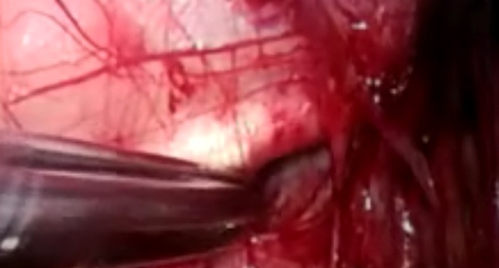
HERNIAL SPACE

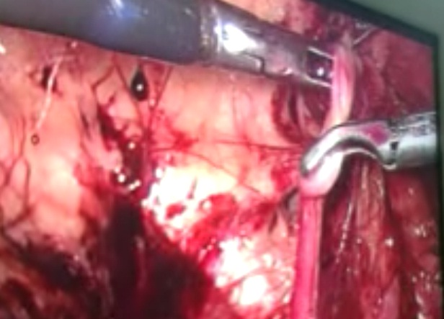
DISSECTION OF SAC
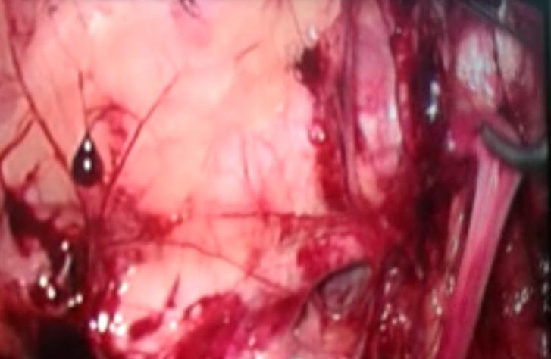
REDUCTION OF HERNIA SAC

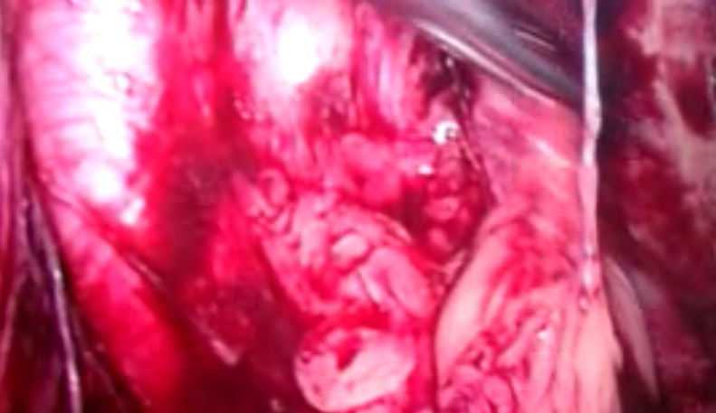 LIPOM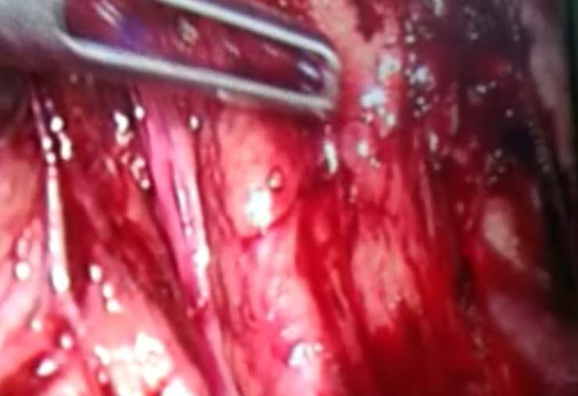 HERNIA
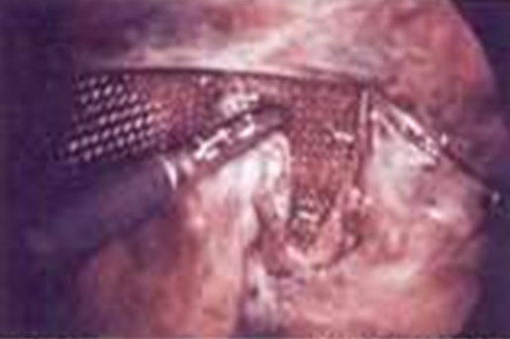
MESH PLACEMENT

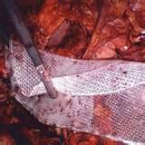
MESH PLACEMENT

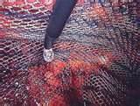
MESH BEING TACKED

SUPPORTING TABLES:

AGE DISTRIBUTION:
Table. 1
Distribution of study subjects by their age.
AGES | FIXATION(n₁=30)  No( %) | NON FIXATION(n₂=30)  No( %)
<21 | 2(6.67) | 1(3.33)
21-30 | 4(13.33) | 5(16.67)
31-40 | 6(20) | 8(26.67)
41-50 | 5(16.67) | 5(16.67)
>50 | 13(43.33) | 11(36.67)
Total | 30(100) | 30(100)

There was 43.33% of inguinal hernia patients in the fixation group and 36.67% in non fixation group belonging to age more than 50 years. It shows inguinal hernia is more common in older age in comparison to young age.
Fig. No . 1
Multiple bar diagram showing distribution by age.

Average age of study subjects:
 | Mean+ SD | t | df | P
Fixation | 44.87+15.014 | 0.174 | 58 | 0.863
Non fixation | 44.20+ 14.684

Mean age in fixation was 44.87 and non fixation group was 44.87, where pair t test = 0.174 and p= 0.863. This shows difference in mean age between two groups was not statistically significant (p= 0.863). So both groups were comparable.

OPRATIVE TIME DISTRIBUTION:
Fig. No . 2-
Multiple bar diagram showing operative time distribution of study subject

Figure-2 depicts 3.33% of fixation and 23.33% of non fixation groups required operative time less than 40 mins,fixation(0) and non fixation (40%) required time 41 to 60 mins, fixation(20%) and non fixation(20%) needed 61 to 80 mins, 81 to 100 mins required in 46.67% of fixation and 16.67% of non fixation group,there was 30% of fixation group required 101 to 120 mins time.

Table 2.
Table on operative time of study subjects.
 | Mean + SD | T | df | P
Fixation | 95.83+18.804 | 7.681 | 58 | .000
Non fixation | 56.83+ 20.489

Table explains mean operative time in fixation group was 95.83 mins and non fixation group was 56.83 mins. So, t= 7.681 and p= .000, it shows difference in operative time between two groups was statistically significant (p = .000).
AVERAGE PAIN SCORE (VAS SCORE):
Fig. No. 3
Average pain score in fixation group:

In this figure no.3 , during post operative period of fixation group average pain score at different interval was 38.67 at 12 hours, 24.33 at 24 hours, 13 at 72 hours , 7.33 at 1month and 4.33 at 6 months.
Fig. No. 4

Average pain score in non fixation group

Figure no. 4 explain in post operative period pain score of non fixation at different interval was 30 at 12 hours, 12.33 at 24 hours, 3.67 at 72 hours and 00 at 1 and 6 months.

Table. No. 3
Average pain score at different stages.
 | Fixation | Non fixation
Different stage | Mean + SD | Mean + SD | t | df | P
12hrs | 38.67+18.889 | 30.00 + 15.97 | 1.919 | 58 | .060
24hrs | 24.33 +16.121 | 12.33 + 13.817 | 3.096 | 58 | .003
72hrs | 13.00 + 15.347 | 3.67+ 6.687 | 3.054 | 58 | .003
1 month | 7.33 + 10.807 | 000 | 3.717 | 58 | .000
6 month | 4.33 + 6.789 | 000 | 3.496 | 58 | .001

Average pain score of fixation (38.67) and non fixation(30) at 12 hours was comparable. whereas at 24 hrs in fixation and non fixation group it was24.33 and 12.33. At 72 hrs fixation and non fixation group it was 13 and 3.67. At 1 month and 6 months in fixation group it was 7.33 and 4.33 whereas in non fixation zero. This signifies more pain in fixation group at 24 hrs, 72 hrs, 1 month and 6 months in comparison to non fixation group. Difference in average pain score at first 12 hrs was not statistically significant (p = .060) but at 24 hrs, 72 hrs, 1 month and 6 months it was statistically significant (p = .003, p = .003, p = .000, p = .001 respectively) .

DURATION OF HOSPITAL STAY:
Fig. No. 5

Figure shows average hospital stay in fixation group was 3.63 days and 2.93 days in non fixation group.
Table. No. 4
Average duration of hospital stay between two groups
 | Mean + SD | t | df | P
Fixation | 3.63+ 0.556 | 3.986 | 58 | .000
Non fixation | 2.93+ 0.785

Average duration of hospital stay in fixation was 3.63 days and non fixation 2.93 days with t = 3.986 and p = .000. Difference in average duration of hospital stay was statistically significant (p = .000)

OPERATIVE COMPLICATIONS:
Fig. No. 6
Pie diagram showing incidence of complications among cases undergoing fixation:

Pie chart shows there was 23.33% intra operative complication in case of fixation of mesh.

Fig. No. 7
Pie chart showing incidence of complications among non fixation group

Pie chart shows only 13.33% complication found in non fixation of mesh.

Table. No. 5
Distribution of operative complication in study group
 | Complicatio  No. (%) | Nocomplication  No. (%) | X² | df | p | OR
Fixation(n₁= 30) | 7(23.33) | 23(76.67) | 0.45 | 1 | 0.504 | 1.98<OR<9.41
Non fixation(n₂=30) | 4(13.33) | 26(86.67)

X² = 0.45
df = 1
p = 0.504
Table shows 7(23.33%) complication was noted in fixation whereas 4(13.33%) was noted in non fixation group, more complication in fixation group, with X²= 0.45 and p= 0.504.So difference in proportion of patient between two groups regarding operative complication was not statistically significant(p = 0.504, OR = 1.98<OR<9.41)
POST OPERATIVE COMPLICATION:
Fig. No. 8
Pie chart showing post operative complication in cases undergoing fixation group

Pie chart explains 20% complication was noted in case of fixation of mesh post operatively.
Fig. No . 9
Pie chart showing complication among non fixation group.

Pie chart shows only 10% complication was noted in non fixation of mesh post operatively.
Table. No. 6
Distribution of post operative complication in study group
 | Complication No. (%) | No complication No. (%) | X² | df | p | OR
Fixation(n₁= 30) | 6(20%) | 24(80%) | 0.45 | 1 | 0.504 | 2.25<OR<12.97
No fixation(n₂=30) | 3(10%) | 27(90%)

X² = 0.45
df = 1
p = 0.504
There was 6(20%) complication post operatively in fixation group and 3(10%) in non fixation group, with X² = 0.45 and p = 0.504. Difference in proportion of patient regarding post operative complication in both group was not statistically significant (p = 0.504, OR = 2.25<OR<12.97)
Fisher exact test – p = 0.472(as expected value of one cell is less than 5)

Table. No. 7
RECURRENCE:
 | RECURRENCE | NO RECURRENCE
FIXATION(n¹=30) | 0(0%) | 30(100%)
NON FIXATION(n²=30) | 0(0%) | 30(100%)

There was no recurrence in both groups during study period.

References :

[Garg P, Nair S, Shereef M, Thakur JD, Nain N, Menon GR, Ismail M et al on Oct 2011] [ Cody A. Koch, Susan M. Greenlee, RN, Dirk R. Larson, Jeffrey R. Harrington, and David R. Farley et al Oct 2006 .] [Tam KW, Liang HH ,Chai CY et al in 2010] [ Khajanchee YS, Urbach DR, Swanstrom LL, Hansen PD et al(6) on October 2001] Teng YJ, Pan SM, Liu YL, Yang KH, Zhang YC, Tian JH, Han JX. A meta-analysis of randomized controlled trials of fixation versus nonfixation of mesh in laparoscopic total extraperitoneal inguinal hernia repair. Surg Endosc. 2011 Sep;25(9):2849-58. ] [Garg P, Nair S, Shereef M, Thakur JD, Nain N, Menon GR, Ismail M et al on Oct 2011 ] [P. RIDINGS and D.S. EVANS. The transabdominal pre-peritoneal (TAPP) inguinal hernia repair: a trip along the learning curve. J.R.Coll.Surg.Edinb. February 2000; 45: 29-32.] [Vishal R. Saggar, Rathindra Sarangi.Laparoscopic Totally Extraperitoneal Repair of Inguinal Hernia A Policy of Selective Mesh Fixation over a 10-Year Period. Journal of Laparoendoscopic and Advanced Surgical Techniques. April 2008; 18(2): 209-212] [Evangelos Messaris, Guy Nicastri, Stanley J. Dudrick. Total Extraperitoneal Laparoscopic Inguinal Hernia Repair without Mesh Fixation. Arch Surg. 2010; 145(4):334-338.] [ Taylor C,Layani L, Liew V, Ghusn M, Crampton N, White S. Laparoscopic inguinal hernia repair without mesh fixation, early results of a large randomised clinical trial. Surg Endosc.2008; 22(30):757-62.] [Hung Lau. Fibrin Sealant Versus Mechanical Stapling for Mesh Fixation During Endoscopic Extraperitoneal Inguinal Hernioplasty. Ann Surg. 2005 November; 242(5): 670–675. ] [Morrison JE Jr, Jacobs VR. Laparoscopic preperitoneal inguinal hernia repair using preformed polyester mesh without fixation: prospective study with 1-year follow-up results in a rural setting. Surg Laparosc Endosc Percutan Tech. 2008 Feb;18(1):33-9].

