Covering letter

To,
The Editor,
Subject: Submission of manuscript for publication

Dear Sir,
We intend to publish an article entitled “Oral health related knowledge, attitude and practice among nursing students of Kathmandu district” in your esteemed journal as Original article. On behalf of all contributors I will act as guarantor and will correspond with the journal from this point onwards. It has not been published and has not been presented in 17th Annual Nepal Dental Association conference on 9th April’2016. The study is self-financed. There are no conflicts of interest. Permissions is nil; as for reproducing or pre published material.
We hereby transfer, assign or otherwise convey all copyright ownership, including any and all rights incidental thereto, exclusively to the journal, in the event that such work is published by the journal.

Thanking you,
Yours sincerely
Dr. Rosina Bhattarai

Corresponding contributor: Dr. Rosina Bhattarai, MDS 1st year, Department of Community Dentistry, Kantipur Dental College and Research Center, Dhapasi, Kathmandu, Nepal
Phone number: +9779841390383
Email id: rosinabhattarai@gmail.com

Declaration signed by authors

I/we certify that I/we have participated sufficiently in contributing to the intellectual content, concept and design of this work or the analysis and interpretation of the data, as well as writing of the manuscript, to take public responsibility for it and have agreed to have my/our name listed as a contributor.
I/we believe that the manuscript represents valid work. Neither this manuscript nor one with substantially similar content under my/our authorship has been published or is being considered for publication elsewhere, except as described in the covering letter.
I/we hereby transfer, assign or otherwise convey all copyright ownership, including any and all rights incidental there to, exclusively to the Journal of College of Medical Sciences in the event that such work is published by the Journal of College of Medical Sciences.
- Dr. Rosina Bhattarai
- Dr. Sunita Khanal
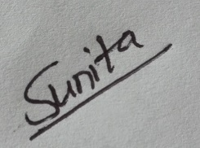

- Prof. Dr. G. Nagaraja Rao
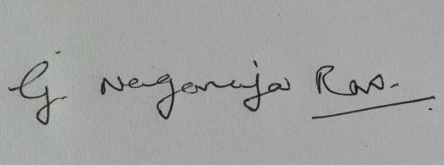
- Dr. Sujita Shrestha
