ORIGINAL RESEARCH ARTICLE

TITLE

EVALUATION OF THE EFFECT OF GABAPENTIN ON POSTOPERATIVE ANALGESIA WITH EPIDURAL MORPHINE AFTER ABDOMINAL HYSTERECTOMY

Diptesh Aryal¹, Renu Gurung¹, Modanath Marhatta¹

¹Department of Anesthesiology, Maharajgunj Medical Campus, Institute of Medicine, Tribhuvan University, Kathmandu, Nepal

Correspondence:

Diptesh Aryal

Department of Anesthesiology, Maharajgunj Medical Campus, Institute of Medicine, Kathmandu, Nepal

Email: diptesharyal@gmail.com

FIGURES

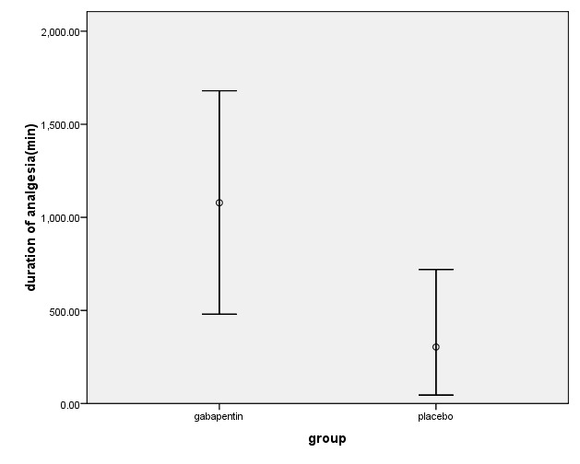

FIGURE 1: Duration of analgesia of first epidural analgesia (maximum, minimum and mean in minutes)

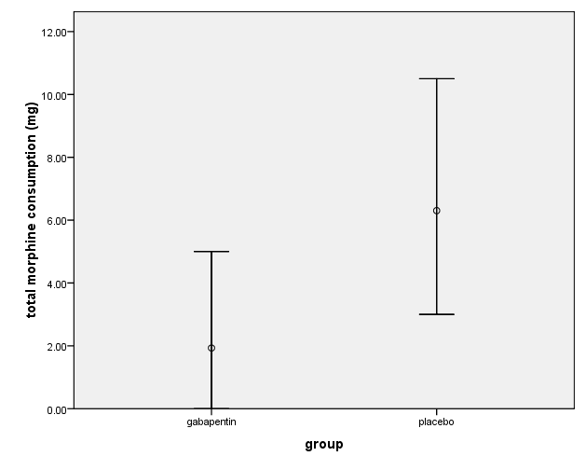
FIGURE 2: Total morphine consumption in 24 h (maximum, minimum and mean)

FIGURE 3: Postoperative Pain Scores in Gabapentin (G) and Placebo (P) Groups

