Authorship Letter
To Date: 15th June 2018
The chief editor
Journal of College of Medical Science
Bharatpur
Subject: Authorship for “Temporomandibular joint disorders and its relationship with parafunctional habits among undergraduate medical and dental students’’

Dear Editor,
Those who have participated sufficiently in the intellectual content, conception and design of this work or the analysis and interpretation of the data, as well as writing of the manuscript, to take public responsibility for being are listed as follows:
Authors Designation
- Dr. Sudeep Acharya Associate Professor
- Dr. Amita Pradhan Professor
- Dr. Rajib Chaulagain Lecturer 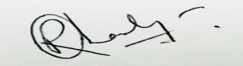,

We hereby agree, Dr. Sudeep Acharya, to be the corresponding author for this article. We give the rights to the corresponding author to make necessary changes as for the request of the journal, do the rest of the correspondence and he will act as the guarantor for the manuscript on our behalf.

Sincerely yours,

Authors
- Dr. Sudeep Acharya
- Dr. Amita Pradhan
- Dr. Rajib Chaulagain ,

